Data Flow Diagrams

A Data Flow Diagram (DFD) is a traditional visual representation of the information flows within a system. A neat and clear DFD can depict the right amount of the system requirement graphically. It shows how data enters and leaves the system, what changes the information, and where data is stored.

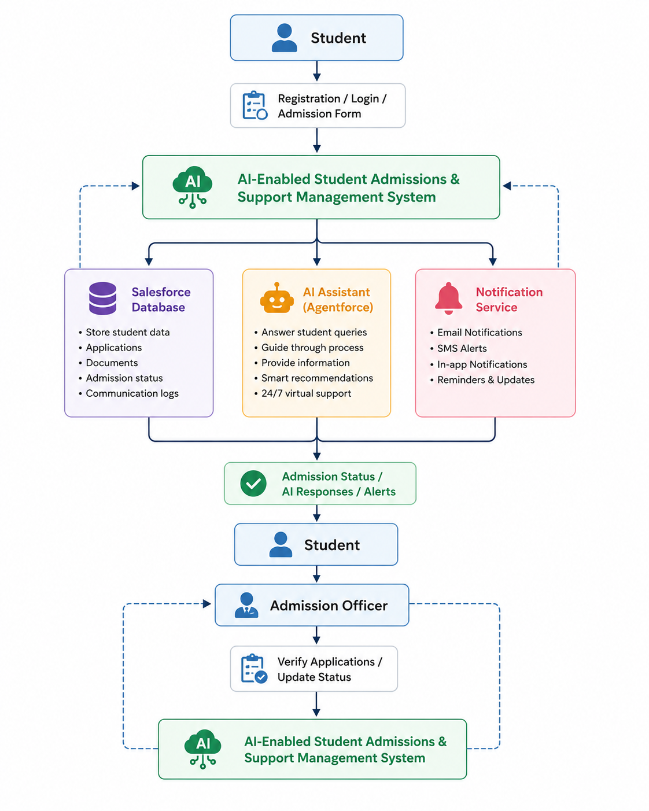
User Stories
User Type | Functional Requirement (Epic) | User Story Number | User Story / Task | Acceptance Criteria | Priority | Release
Student | Registration | USN-1 | As a student, I can register using my personal details so that I can apply for admission. | Student account is successfully created. | High | Sprint-1
Student | Login | USN-2 | As a student, I can securely log into the portal using my credentials. | Student can access the dashboard. | High | Sprint-1
Student | Admission Application | USN-3 | As a student, I can fill out and submit my admission application online. | Application is successfully submitted. | High | Sprint-1
Student | Document Upload | USN-4 | As a student, I can upload required academic documents. | Documents are uploaded and stored securely. | High | Sprint-1
Student | Application Tracking | USN-5 | As a student, I can track my admission status in real time. | Updated application status is displayed. | High | Sprint-2
Student | AI Support | USN-6 | As a student, I can ask admission-related questions to the AI assistant. | AI provides accurate and relevant responses. | Medium | Sprint-2
Admission Officer | Application Management | USN-7 | As an admission officer, I can review and verify student applications. | Officer can approve or reject applications. | High | Sprint-1
Admission Officer | Status Update | USN-8 | As an admission officer, I can update the admission status of applicants. | Students receive updated admission status. | High | Sprint-2
Admission Officer | Student Communication | USN-9 | As an admission officer, I can send notifications to students regarding admission updates. | Students receive email or system notifications. | Medium | Sprint-2
Administrator | User Management | USN-10 | As an administrator, I can manage student and admission officer accounts. | User accounts can be created, updated, or removed. | High | Sprint-1
Administrator | Dashboard & Reports | USN-11 | As an administrator, I can view admission statistics and reports. | Reports are generated successfully. | Medium | Sprint-3
Administrator | AI Configuration | USN-12 | As an administrator, I can configure AI knowledge and workflows for student support. | AI assistant functions correctly with updated knowledge. | Low | Sprint-3

